Skill 10 - Lab 4 - Configuring Static NAT
Beginner CCNA lab using Cafe01-RT01 in the Coffee Shop topology
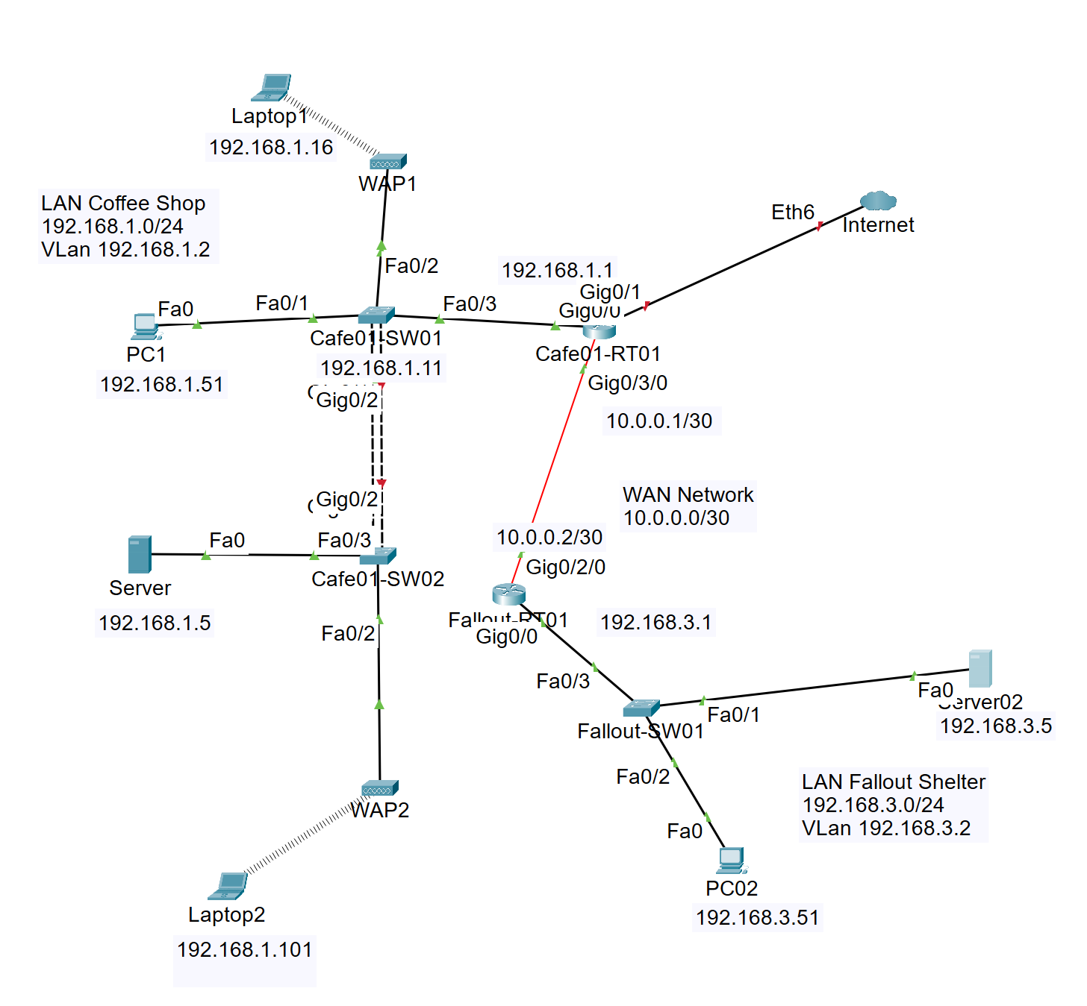
Figure 1. Network used for this Static NAT lab. The main configuration focus is Cafe01-RT01 and Fallout-RT01

Field Briefing
The Coffee Shop network already has a working LAN, switch infrastructure, a router named Cafe01-RT01, a WAN link toward Fallout-RT01, and an Internet-facing connection. In this lab, you will focus on Cafe01-RT01 and configure one-to-one Static NAT so an inside Coffee Shop server can be represented by a public inside-global address.
Note: This lab teaches Static NAT, not Dynamic NAT. Static NAT creates a permanent one-to-one mapping. That is why an outside device can ping or reach the public NAT address even before the inside device starts traffic, as long as routing and firewall behavior allow it.

Lab Objectives
- Identify the NAT inside interface and NAT outside interface on Cafe01-RT01.
- Configure a static NAT mapping for the Coffee Shop Server at 192.168.1.5.
- Verify the default route and other static routes used by Cafe01-RT01.
- Learn how to remove an incorrect static route with the no ip route command.
- Learn how to remove an existing Static NAT statement with the no ip nat command.
- Verify Static NAT with ping, show ip nat translations, show ip nat statistics, and show running-config.

Suggested Access Credentials
Device access | Value
Console / VTY username | cisco
Console / VTY password | cisco
Privileged EXEC secret | CrC0ffee!

Addressing Plan
Device | Interface | Address / Mask | Purpose
PC1 | Fa0 | 192.168.1.51 /24 | Coffee Shop wired client
Laptop1 | Wireless | 192.168.1.16 /24 | Coffee Shop wireless client through WAP1
Server | Fa0 | 192.168.1.5 /24 | Inside host that will be published with Static NAT
Laptop2 | Wireless | 192.168.1.101 /24 | Coffee Shop wireless client through WAP2
Cafe01-SW01 | VLAN 1 | 192.168.1.11 /24 | Switch management address shown in topology
Cafe01-SW02 | VLAN 1 | 192.168.1.12 /24 | Suggested switch management address if needed
Cafe01-RT01 | LAN-facing interface | 192.168.1.1 /24 | Default gateway for Coffee Shop LAN / NAT inside
Cafe01-RT01 | Internet-facing interface | 216.0.5.2 /30 | Outside link toward ISP or Internet simulation / NAT outside
Internet / ISP side | Connected to Cafe01-RT01 | 216.0.5.1 /30 | Next hop for Cafe01-RT01 default route
Cafe01-RT01 | WAN to Fallout-RT01 | 10.0.0.1 /30 | Point-to-point WAN link; not used as Internet NAT outside in this lab
Fallout-RT01 | WAN to Cafe01-RT01 | 10.0.0.2 /30 | Remote router WAN side
Fallout LAN | Gateway | 192.168.3.1 /24 | Remote Fallout Shelter LAN
Server02 | Fa0 | 192.168.3.5 /24 | Remote server in Fallout LAN
PC02 | Fa0 | 192.168.3.51 /24 | Remote client in Fallout LAN

Note: The uploaded image does not display a public IP on the Internet-facing link. This lab uses 216.0.5.1/30 for the upstream ISP/Internet side and 216.0.5.2/30 for Cafe01-RT01, matching your previous NAT practice style. If your Packet Tracer file uses a different outside subnet, replace the 216.0.5.x addresses with your actual addresses.

Static NAT Mapping Plan
Inside local address | Inside global address | Purpose
192.168.1.5 | 216.0.5.20 | Required: publish the Coffee Shop Server to the outside network
192.168.1.51 | 216.0.5.21 | Optional challenge: publish PC1 with a second one-to-one static NAT mapping

Note: Do not configure 216.0.5.20 or 216.0.5.21 directly on the PC, server, or Cafe01-RT01 interface. They are NAT inside-global addresses. The upstream ISP must have return routes pointing these addresses back to Cafe01-RT01 at 216.0.5.2.

Static NAT Terms in This Lab
Term | Meaning in this topology
Inside local | The real private address on the Coffee Shop LAN, such as 192.168.1.5.
Inside global | The public address that represents the inside host on the outside network, such as 216.0.5.20.
Outside global | The real address of an outside device, such as an Internet host or ISP router address.
ip nat inside | Marks the Coffee Shop LAN-facing interface on Cafe01-RT01 as the inside NAT zone.
ip nat outside | Marks the Internet-facing interface on Cafe01-RT01 as the outside NAT zone.
Static NAT | A permanent one-to-one mapping between one inside local address and one inside global address.

Task 1 - Verify the Topology and Identify Interfaces
Objective: Do not guess interface names. First identify which interface on Cafe01-RT01 connects to the Coffee Shop LAN, which interface connects to the Internet, and which interface connects to Fallout-RT01.
Focus commands on Cafe01-RT01
show ip interface brief
show cdp neighbors
show running-config | section interface
show ip route

- Find the interface with 192.168.1.1. This is the Coffee Shop LAN interface and will become ip nat inside.
- Find the interface that faces the Internet or ISP. In this lab it uses 216.0.5.2/30 and will become ip nat outside.
- Find the interface with 10.0.0.1/30. This is the WAN link to Fallout-RT01. Do not use it as the Internet NAT outside interface for this lab.

Task 2 - Configure Basic Access on Cafe01-SW01 and Cafe01-SW02
Objective: Make the Coffee Shop switches reachable for management. These commands are included for beginner practice. If your switches already work, verify instead of retyping everything.
Cafe01-SW01 sample configuration
enable
configure terminal
hostname Cafe01-SW01
no ip domain-lookup
username cisco secret cisco
enable secret CrC0ffee!
service password-encryption
!
interface vlan 1
description Management SVI
ip address 192.168.1.11 255.255.255.0
no shutdown
exit
ip default-gateway 192.168.1.1
!
interface fastethernet0/1
description To PC1
switchport mode access
spanning-tree portfast
exit
interface fastethernet0/2
description To WAP1
switchport mode access
spanning-tree portfast
exit
interface fastethernet0/3
description To Cafe01-RT01 LAN interface
switchport mode access
exit
!
line console 0
login local
exit
line vty 0 4
login local
exit
end
copy running-config startup-config

Cafe01-SW02 sample configuration
enable
configure terminal
hostname Cafe01-SW02
no ip domain-lookup
username cisco secret cisco
enable secret CrC0ffee!
service password-encryption
!
interface vlan 1
description Management SVI
ip address 192.168.1.12 255.255.255.0
no shutdown
exit
ip default-gateway 192.168.1.1
!
interface fastethernet0/2
description To WAP2
switchport mode access
spanning-tree portfast
exit
interface fastethernet0/3
description To Server 192.168.1.5
switchport mode access
spanning-tree portfast
exit
!
line console 0
login local
exit
line vty 0 4
login local
exit
end
copy running-config startup-config

Note: If you use only VLAN 1 in Packet Tracer, the switch links usually work with default access settings. If your teacher wants trunks between switches, configure the inter-switch Gigabit link as switchport mode trunk on both switches.

Task 3 - Configure Cafe01-RT01 Interfaces and Static Routes
Objective: Build the routing foundation before NAT. Static NAT will fail if Cafe01-RT01 does not know how to reach outside networks or if the ISP cannot return traffic to the NAT public address.
Focus idea
interface <LAN-facing-interface>
ip nat inside
!
interface <Internet-facing-interface>
ip nat outside
!
ip route 0.0.0.0 0.0.0.0 <ISP-next-hop>

Cafe01-RT01 baseline configuration
enable
configure terminal
hostname Cafe01-RT01
no ip domain-lookup
username cisco secret cisco
enable secret CrC0ffee!
service password-encryption
!
interface gigabitethernet0/1
description To Cafe01-SW01 - Coffee Shop LAN
ip address 192.168.1.1 255.255.255.0
no shutdown
exit
!
interface gigabitethernet0/0/0
description To Internet or ISP - NAT outside
ip address 216.0.5.2 255.255.255.252
no shutdown
exit
!
interface gigabitethernet0/3/0
description WAN to Fallout-RT01
ip address 10.0.0.1 255.255.255.252
no shutdown
exit
!
ip route 0.0.0.0 0.0.0.0 216.0.5.1
ip route 192.168.3.0 255.255.255.0 10.0.0.2
!
line console 0
login local
exit
line vty 0 4
login local
exit
end
copy running-config startup-config

Note: Your Packet Tracer router may use different interface names, such as GigabitEthernet0/0, GigabitEthernet0/1, or Ethernet6. Use show ip interface brief and replace the interface names in the commands with the names in your device.

Task 4 - Check, Remove, and Correct Static Routes
Objective: Learn the safe way to remove a wrong static route. Static routes are removed with the same command that created them, but with no at the beginning.
How to remove a static route
show running-config | include ^ip route
configure terminal
no ip route <destination-network> <subnet-mask> <next-hop>
end

Step 1: Display only static routes
show running-config | include ^ip route

Step 2: Example cleanup commands if routes are wrong
configure terminal
no ip route 0.0.0.0 0.0.0.0 10.0.0.2
no ip route 192.168.3.0 255.255.255.0 216.0.5.1
end

Step 3: Add the correct static routes
configure terminal
ip route 0.0.0.0 0.0.0.0 216.0.5.1
ip route 192.168.3.0 255.255.255.0 10.0.0.2
end
copy running-config startup-config

Note: Do not try to remove connected routes. Routes marked C in show ip route are created automatically from interface IP addresses. Only routes marked S or S* are static routes you configured with ip route.

Task 5 - Remove Old NAT Statements Before Building Static NAT
Objective: Clean up old Dynamic NAT or old Static NAT configuration so you know exactly what is active on Cafe01-RT01.
Check existing NAT configuration
show running-config | include ip nat
show access-lists
show ip nat translations
show ip nat statistics

Cleanup commands
enable
clear ip nat translation *
configure terminal
!
! Remove old Static NAT examples if they exist.
no ip nat inside source static 192.168.1.5 216.0.5.20
no ip nat inside source static 192.168.1.51 216.0.5.21
!
! Remove old Dynamic NAT example if it exists.
no ip nat inside source list 10 pool CAFE_POOL
no ip nat pool CAFE_POOL 216.0.5.20 216.0.5.21 netmask 255.255.255.0
no access-list 10
end

Note: If a no command does not match anything on the router, the router may display a small message or simply return to the prompt. That is okay. The goal is to make sure old NAT lines are gone before you configure the new Static NAT lines.

Task 6 - Configure Static NAT on Cafe01-RT01
Objective: Create the permanent one-to-one NAT mapping. This is the main task of the lab.
Core Static NAT commands to memorize
interface gigabitethernet0/1
ip nat inside
!
interface gigabitethernet0/0/0
ip nat outside
!
ip nat inside source static 192.168.1.5 216.0.5.20

Static NAT configuration on Cafe01-RT01
enable
configure terminal
!
interface gigabitethernet0/1
description To Cafe01-SW01 - Coffee Shop LAN
ip nat inside
exit
!
interface gigabitethernet0/0/0
description To Internet or ISP - NAT outside
ip nat outside
exit
!
ip nat inside source static 192.168.1.5 216.0.5.20
!
! Optional second static NAT mapping for PC1:
! ip nat inside source static 192.168.1.51 216.0.5.21
end
copy running-config startup-config

Note: The inside local address is 192.168.1.5. The inside global address is 216.0.5.20. The command reads from left to right: translate inside source static from private address to public address.

Task 7 - Configure ISP Return Route for the NAT Address
Objective: Make sure the outside network knows that 216.0.5.20 lives behind Cafe01-RT01. This is usually configured on the ISP router, not on Cafe01-RT01.
ISP or Internet-router return route example
enable
configure terminal
!
interface gigabitethernet0/0
description To Cafe01-RT01
ip address 216.0.5.1 255.255.255.252
no shutdown
exit
!
ip route 216.0.5.20 255.255.255.255 216.0.5.2
!
! Optional if you configured PC1 static NAT:
! ip route 216.0.5.21 255.255.255.255 216.0.5.2
end
copy running-config startup-config

Note: If your topology uses a Packet Tracer Internet cloud instead of an ISP router, you may need to add a route in the device behind the cloud, or replace the cloud with a simple ISP router for easier CCNA testing.

Task 8 - Verify Static NAT
Objective: Prove that the inside server is represented by the public address 216.0.5.20.
Cafe01-RT01 verification commands
show ip interface brief
show ip route
show running-config | include ip nat
show running-config interface gigabitethernet0/1
show running-config interface gigabitethernet0/0/0
show ip nat translations
show ip nat statistics

From Server 192.168.1.5 or PC1
ping 192.168.1.1
ping 216.0.5.1
ping 8.8.8.8

From the ISP or outside router
ping 216.0.5.20
traceroute 216.0.5.20
show ip route 216.0.5.20

Expected result | What it proves
Inside device can ping 192.168.1.1 | The local LAN and default gateway are working.
Cafe01-RT01 can ping 216.0.5.1 | The Internet-facing link is working.
show ip nat translations shows 216.0.5.20 mapped to 192.168.1.5 | The Static NAT mapping exists.
Outside router can ping 216.0.5.20 | The outside network can reach the server through Static NAT.

Task 9 - Troubleshooting Checklist
- If Server 192.168.1.5 cannot ping 192.168.1.1, fix the LAN before troubleshooting NAT.
- If Cafe01-RT01 cannot ping 216.0.5.1, fix the Internet-facing link before troubleshooting NAT.
- If show ip nat translations does not show a static entry, check the ip nat inside source static command.
- If the outside router cannot ping 216.0.5.20, check the ISP return route to 216.0.5.20/32 through 216.0.5.2.
- If NAT is configured but traffic fails, verify that the LAN interface is ip nat inside and the Internet-facing interface is ip nat outside.
- Do not use the Fallout WAN interface as ip nat outside unless the lab specifically says NAT must go toward Fallout-RT01.
- Do not place 216.0.5.20 on the server. The server keeps 192.168.1.5.

Task 10 - Remove Static NAT and Static Routes
Objective: Learn how to safely remove the Static NAT lab configuration. This is useful when you need to rebuild the lab from scratch or fix a wrong command.
Removal commands to memorize
no ip nat inside source static 192.168.1.5 216.0.5.20
no ip route 0.0.0.0 0.0.0.0 216.0.5.1

Remove Static NAT configuration from Cafe01-RT01
enable
clear ip nat translation *
configure terminal
!
no ip nat inside source static 192.168.1.5 216.0.5.20
no ip nat inside source static 192.168.1.51 216.0.5.21
!
interface gigabitethernet0/1
no ip nat inside
exit
interface gigabitethernet0/0/0
no ip nat outside
exit
end

Remove static routes from Cafe01-RT01
show running-config | include ^ip route
configure terminal
no ip route 0.0.0.0 0.0.0.0 216.0.5.1
no ip route 192.168.3.0 255.255.255.0 10.0.0.2
end
copy running-config startup-config

Note: The no ip route command must match the original route exactly: destination network, subnet mask, and next-hop address. If one value is different, the route will not be removed.

Lab Completion Key
Check item | Expected value
Coffee Shop LAN | 192.168.1.0/24
Cafe01-RT01 LAN gateway | 192.168.1.1
NAT inside interface | Cafe01-RT01 interface facing Cafe01-SW01
NAT outside interface | Cafe01-RT01 interface facing Internet or ISP
Required Static NAT | 192.168.1.5 mapped to 216.0.5.20
Cafe01-RT01 default route | 0.0.0.0/0 via 216.0.5.1
ISP return route | 216.0.5.20/32 via 216.0.5.2
Verification command | show ip nat translations

Complete Cafe01-RT01 Answer Configuration
Cafe01-RT01 final answer
hostname Cafe01-RT01
!
interface gigabitethernet0/1
description To Cafe01-SW01 - Coffee Shop LAN
ip address 192.168.1.1 255.255.255.0
ip nat inside
no shutdown
!
interface gigabitethernet0/0/0
description To Internet or ISP - NAT outside
ip address 216.0.5.2 255.255.255.252
ip nat outside
no shutdown
!
interface gigabitethernet0/3/0
description WAN to Fallout-RT01
ip address 10.0.0.1 255.255.255.252
no shutdown
!
ip nat inside source static 192.168.1.5 216.0.5.20
!
! Optional:
! ip nat inside source static 192.168.1.51 216.0.5.21
!
ip route 0.0.0.0 0.0.0.0 216.0.5.1
ip route 192.168.3.0 255.255.255.0 10.0.0.2

Final Completion Checklist
☐ Server is 192.168.1.5/24 with default gateway 192.168.1.1.
☐ Cafe01-RT01 LAN-facing interface is ip nat inside.
☐ Cafe01-RT01 Internet-facing interface is ip nat outside.
☐ Cafe01-RT01 has ip nat inside source static 192.168.1.5 216.0.5.20.
☐ Cafe01-RT01 has a default route pointing to the ISP/Internet next hop.
☐ The outside router or ISP has a route for 216.0.5.20 pointing to 216.0.5.2.
☐ show ip nat translations displays the static mapping.
☐ An outside device can test reachability to 216.0.5.20.

